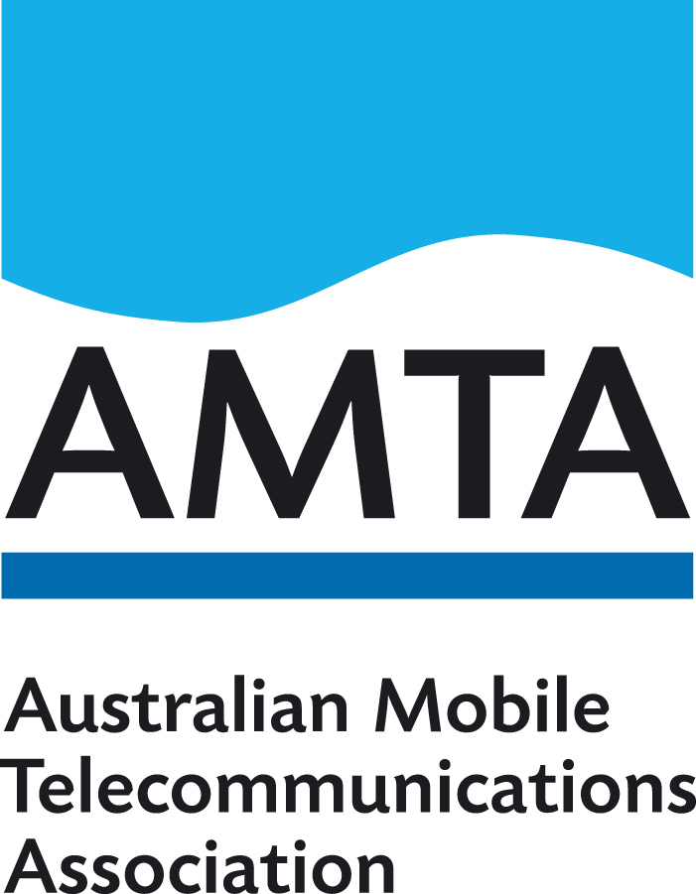
Submission to the
Regional Telecommunications Review 2018

Joint submission by:
Communications Alliance
Australian Mobile Telecommunications Association (AMTA)

6 August 2018

Contents
Introduction 3
Responses to Questions 4
How are regional Australians using telecommunications services? 4
Remote Indigenous Communities 5
Digital Literacy 6
National Broadband Network 6
Mobile Coverage 6
Alternative and emerging technologies 7
Re-thinking consumer protections and policies 9

Communications Alliance (CA) is the primary telecommunications industry body in Australia. Its membership is drawn from a wide cross-section of the communications industry, including carriers, carriage and internet service providers, content providers, equipment vendors, IT companies, consultants and business groups.
Its vision is to provide a unified voice for the telecommunications industry and to lead it into the next generation of converging networks, technologies and services. The prime mission of Communications Alliance is to promote the growth of the Australian communications industry and the protection of consumer interests by fostering the highest standards of business ethics and behaviour through industry self-governance. For more details about Communications Alliance, see http://www.commsalliance.com.au.

The Australian Mobile Telecommunications Association (AMTA) is the peak industry body representing Australia’s mobile telecommunications industry. Its mission is to promote an environmentally, socially and economically responsible, successful and sustainable mobile telecommunications industry in Australia, with members including the mobile carriage service providers, handset manufacturers, network equipment suppliers, retail outlets and other suppliers to the industry. For more details about AMTA visit http://www.amta.org.au.

Introduction
CA and AMTA (the Associations) welcome the opportunity to provide this submission to the Regional Telecommunications Review 2018. Access to telecommunications is important for all Australians, and those in regional, rural, and remote parts of Australia face unique challenges in accessing and utilising telecommunications.
There have been significant improvements in the three years since the 2015 review, including increased choice, access, and data allowances through the nbn rollout and investment in mobile networks.
With these improvements in access, we fully support the Committee’s intention to examine how access can be best leveraged. Regional communities are already finding creative ways to use digital technologies, and Industry looks forward to continuing working with them.
Providing telecommunications access to rural and remote communities is challenging for all countries. This can be seen by the experience in the United States, outlined in this article, which has a much higher population density. With the lowest population density of OECD countries, and 4th lowest in the world, Australia faces additional and unique challenges in increasing access.
However, Australia has led globally in its dedication to providing services to all Australians, as shown in this 2017 Ovum report. In fact, Australia was ranked first on connectivity by the GSMA’s Mobile Connectivity Index in both 2016 and 2017.
Advances in technology will continue this positive trend, as mobile network operators are preparing for and investing in 5G mobile networks as well as continuing to invest in 4G, and developments in satellite technology may provide global coverage within 10 years.
In the nearer future, Optus, Telstra, and Vodafone Hutchison Australia (VHA) have agreed to implement common terminology for coverage maps, and AMTA’s Mobile Carriers Forum have come to an agreement which will support potential co-building and planning coordination in mobile deployment.
Successful efforts by retail service providers (RSPs), nbn, and government to expand access have resulted in job creation in regional areas and are supporting Australians across the country to engage in the digital economy.

Responses to Questions
The Associations support the Committee’s consideration of how best to support regional communities and consumers to maximise the benefits of digital technologies and broadband services. Many of the specific questions on these topics can be best addressed by regional consumers themselves. Thus, we have offered responses to the questions on which the Associations can offer relevant expertise, and welcome further dialogue with the Committee.

How are regional Australians using telecommunications services?
- What are the main barriers to people in regional communities increasing their use of digital technologies and possible solutions for overcoming these barriers?
- How are people in regional communities currently using their broadband service and how might they increase the benefits of using this technology?
- What data-intensive activities are occurring in regional, rural and remote Australia? What digital technologies are needed for these?
- How can regional businesses better utilise digital technologies to maximise economic benefits?
We acknowledge that one of the challenges regional communities face in the uptake of digital technologies is the quality of their service, both speed and download capabilities. There are ongoing upgrades and innovation to overcome this challenge. As discussed in the introduction, we have seen significant changes in the last three years, and there are continued planned improvements. The Access gap, as measured by the Australian Digital Inclusion Index, is narrowing each year.
As more Australians gain internet access through the roll-out of these technologies, they actively use the internet, and may face data and/or speed limitations. However, the increase of speed and data limitations is being addressed aggressively, and the growth of data-intensive activities, such as using streaming video for tele-health or education programs, is being paralleled by the increasing efficiency of data transfer rates.
However, lower levels of digital inclusion in rural, regional, and remote communities are still present, due to a number of factors. One of these barriers is digital literacy, addressed later in this submission.
Despite these barriers, rural and regional businesses are already taking advantage of their increased access to broadband, creating new businesses and increasing their reach and customer bases.
In addition to businesses leveraging digital technologies and employment, people in regional and remote communities use digital technologies to access a range of services, as they are often unable to conveniently get to offices. These include government essential service websites, which are often data heavy and/or not mobile accessible. We recommend that Government audit essential service websites and online applications such as MyGov to ensure that they are mobile-device accessible and continually updated to prevent problems with use. This would also include justice, health, and other services.

Remote Indigenous Communities
- What can be done to improve access and uptake of telecommunications services in remote Indigenous communities?
- Are there practical examples of how communications services can improve the well-being of people in remote Indigenous communities?
Access to communications services can improve the well-being of people in all communities, and this is equally true in remote Indigenous communities. Benefits include access to tele-health services and access to specialist care, which is useful for all remote and regional communities. Specific opportunities for remote Indigenous communities can include sharing language and stories, digital archiving and genealogy mapping technology, conducting research, and enabling communities to share their stories through digital technology such as video storytelling.
However, remote Indigenous Communities can face unique challenges in adopting telecommunications services. While mobile phone coverage is limited, where it is available cost can be a significant barrier to entry, both the initial establishment cost and ongoing costs as part of a post-paid plan. Therefore, prepaid services have proven to be popular choice to avoid overspend, however access to a prepaid service can be difficult as a result of regulation. The Telecommunications (Service Provider - Identity Checks for Prepaid Mobile Carriage Services) Determination 2017 (the Determination) requires quite specific forms of ID to be presented before a service provider can active a prepaid mobile service.
CSPs have found it difficult to activate services for remote Indigenous communities as a result of potential customers not having a useful valid ID type, and that Indigenous Community members find it easier to relay their Centrelink Customer Reference Number (CRN). These community members also sometimes face problems simply due to their remote location and distance from a service provider store which means they do not have the option of travelling to a store to complete a visual check if needed.
Industry members have previously proposed (via AMTA) that the government Document Verification Service (DVS) should build a link into Centrelink, in order to make this ID type available for verification. The addition of Centrelink CRNs to the DVS would also help to serve other customers who also lack sufficient ID documentation.
Industry notes, however, that the introduction of Centrelink into DVS may not resolve the issue faced by Indigenous community members in remote and rural areas with no nearby CSP stores who therefore can’t have their ID visually checked. One other suggestion previously put forward is that of allowing customers to have a Justice of the Peace or police sergeant visually check the ID and communicate that with CSPs. While this process will need to be further developed, it should be prioritised to limit the adverse impact of the current Determination on the ability of people living in Indigenous communities to activate prepaid mobile services. The ACMA has been considering this issue for some time, but to date there is no suitable resolution.
The Associations consider that there are a range of actions which would directly support uptake and maximisation of the benefit of telecommunications in remote Indigenous communities. In addition to the above, two recommendations we can offer are to support Better Broadband for the Bush’s call for Digital Inclusion as a key commitment in the Closing the Gap agenda, and to increase government support of culturally appropriate and indigenous run digital capability programs.

Digital Literacy
Digital literacy, or lack thereof, can be a key barrier to uptake of digital technologies. By increasing digital literacy, people’s attitudes and confidence improve. Improving ‘Digital Ability’ (per the Digital Inclusion Index) should be a priority for policy makers, including by coordinating between national, state, and local programs.
7. What skills do people need to get the most from their digital technologies, and where can they learn these skills?

The eSafety Office’s work on educating and empowering a range of Australians, through programs such as education for senior Australians and giving people access to tools to prevent and/or fight back against online abuse, should be commended and continued. Coordination between their activities and the excellent work of organisations such as the Country Women’s Association and the Isolated Children’s Parents Association would be beneficial.

National Broadband Network
- Have you had ongoing issues affecting your satellite or fixed wireless broadband service? If so, how have you overcome these issues?
- If you are in an area with access to the Sky Muster satellite service and you have not taken it up, why not?

Satellite
Since launching the Sky Muster™ satellite service in April 2016, more than 90,000 end users have connected to services over the nbn™ broadband access network. The Sky Muster network is capable of delivering up to 25/5 Mbps wholesale speeds and helps give retail service providers the opportunity to offer a large range of monthly data allowance plans.
In the first year of operation the Sky Muster™ satellite service peaked at 10,000 activations in November 2016 which was an unprecedented volume for the roll-out of a consumer satellite broadband service in Australia. Special provisions were made for additional data specifically for remote school of the air students and indigenous communities.
Like any new technology, nbn experienced some network issues early on the Sky Muster™ satellite service, particularly given the high volume of connections. However nbn has worked closely with vendors, stakeholders and service providers and within the first year, network stability was performing to industry best practice when benchmarked against other comparable Ka band high throughput satellite networks. Independent Customer Satisfaction surveys showed the improvement in network stability was reflected in overall end user customer satisfaction. In Oct 2017 the Sky Muster™ satellite service won the international Berlin 2017 Broadband Award for “Broadband Delivering Social Impact” and nbn also won the Comms Day 2018 award for “Best Satellite Operator”.
nbn continues to work with service providers and stakeholders to help improve the experience for end users. This includes working on enhancing the Sky Muster™ satellite service to help give service providers the opportunity to introduce more innovative managed plans and developing nbn™ Business Satellite Services which are currently scheduled for launch in Q1 2019.
Fixed Wireless
nbn launched Fixed Wireless in October 2012, it currently serves over 244,000 end users across Australia. Recently, there has been a greater than forecasted amount of data being used, particularly in peak times. In addition to more data being used over a longer period of time, nbn is seeing a notable increase in concurrent users. This is often referred to as the 'Netflix effect' where many households sit down after dinner to stream their favourite show.
Due to this increase in demand, nbn has invested in an upgrade program to help expand the wholesale capacity of our wireless towers. As with any wireless broadband solution, capacity is not infinite and needs to be carefully monitored and managed in order to deliver a network that can help provide the best end user customer experience.
nbn systematically upgrades fixed wireless towers to fit them with greater wholesale data capacity, giving priority to areas where users are experiencing the most congestion. nbn will continue to work with retailers, industry and government to help provide access to a consistent and reliable service on the nbn fixed wireless network.

Mobile Coverage
- What economic or social indicators could be used to guide investment to further improve mobile coverage?
- Is information readily available regarding how to use devices to improve mobile reception in areas with poor coverage? e.g. information about external antenna equipment?

Improvement in speed, technology, and coverage of mobile networks will continue to benefit rural, regional, and remote Australians. Australia’s mobile network operators (MNOs) are preparing for and investing in 5G, the next generation of mobile networks and services, while also continuing to invest in 4G networks which will remain part of the mobile network ecosystem for some time. 5G, building on 4G, will continue to enhance the role of mobile telecommunications as a driver and enabler of productivity and connectivity throughout Australia’s economy and society.
5G will support new and diverse services and applications – from smart agriculture and automated vehicles to smart industrial systems. The impact from 5G is expected to be transformative like no previous mobile generation, with significant impacts on the way we live and work. 5G networks will be faster, more responsive, with greater capacity and lower latency with the ability to handle 10s of billions of devices and connections.
As to current services, AMTA has been working with its members, following the ACCC’s Regional Mobile Issues Forum in February 2018, to look at ways coverage map information can be improved for consumers. As a starting point, Optus, Telstra and VHA have agreed to implement common terminology for the basic levels of coverage to be used when publishing coverage maps. Currently mobile network operators use different terms to mean similar things, adding to customer confusion and making ‘like for like’ comparison more difficult. Agreeing common terms and definitions for the basic coverage layers removes a point of customer confusion and provides a shared point of reference for AMTA members to improve comparability of their coverage maps.
To supplement the agreed terminology, AMTA members are also drafting an AMTA factsheet on coverage maps and coverage information – including how customers can improve reception - that would be made available to customers on the AMTA website.
AMTA members have also been working together to develop a co-building process, that will enable members of AMTA’s Mobile Carriers Forum (MCF) (Optus, Telstra, TPG and VHA) to proactively share deployment plans for regional and remote areas on a regular basis, and in an agreed format, within a defined timeframe, so that other MCF carriers could consider co-building and therefore sharing costs associated with development and planning applications and building of infrastructure.

Alternative and emerging technologies
- What emerging digital services will be of most benefit to regional businesses and what are the data needs of these services?
- What broadband services are people using other than those available through the NBN?
- How can more competition be encouraged in the provision of broadband services in regional Australia?

Emerging technologies will impact all Australians, and there will be significant benefits to regional businesses and opportunities for them to engage more actively in the digital economy.
The expanding internet of things (IOT) will support developments in agriculture, transport, and a range of other areas. This also gives businesses in regional and remote communities opportunities to build programs for IOT platforms and innovate new solutions for their unique challenges. To encourage this development, we recommend continued investment in nationwide ubiquitous connectivity infrastructure (the continued roll-out of the NBN, free public WiFi etc.).
Additionally, the evolution of satellite technology will have positive impacts on access to services across Australia. “Next generation” satellite systems are declining in cost and increasing coverage. For example, OneWeb is building a ‘constellation’ of satellites with the goal of making the internet available to everyone on Earth by 2027.
Communications Alliance’s Satellite Services Working Group (SSWG) has provided some technical information on the development of satellite technologies below, and would be pleased to further engage with the Committee to discuss how these will benefit rural, regional, and remote consumers.
Satellite Technology
There is a range of notable satellite operators already active in Australia, including Optus, Telstra, NBN (Sky Muster), Ipstar, Omnispace, Orion Satellite Systems, SES, Space Systems Loral, Speedcast, Intelsat, Viasat, and Inmarsat. Historically, commercial communications satellite networks have been typically geostationary orbit (GSO) networks, whilst lower orbit systems are now coming on to the scene. While GSO networks require fewer satellites and relatively simple ground equipment (pointing to a fixed “stationary” satellite), they can be costly (a propagation distance of 36,000 km requires large antennas to boost the signal adequately). There are new technologies expanding and scheduled to be launched in the coming years, with significantly lower costs and the ability to make satellite access more economic to rural, regional, and remote communities. This is through either higher power and more efficient GSO satellites, or through lower orbit designs.
During the past decade many satellite operators have launched High Throughput Satellites (HTS) in GSO operating in the Ka-band (20/30 GHz) and/or the Ku-band (11/14 GHz). The main innovation in these satellites is in bringing faster Internet connectivity such as provided by nbn’s ‘SkyMuster’ satellites, Thaicom’s IPStar and satellites of other fixed satellite services (FSS) operators. Many more such satellites are ordered and under construction and will launch from 2018. The satellite antennas of these HTSs are typically characterized by many small beams (up to about 200) with high gain and this allows for links to relatively small user terminals and more concentrated footprints to specific areas of Australia.
More recently, a number of new HTS non-GSO satellite networks have been launched (e.g. O3b) and/or announced (e.g. OneWeb, SpaceX, LEOSat, etc.) with the intention of connecting the unconnected using a variety of frequency bands. This is of significant importance to regional and remote communications in Australia. Whilst satellite networks have to date faced large initial capital costs, the new non-GSO networks are more scalable and are expected to provide high quality, low latency services to a world that is presently underserved with always-on broadband. Both GSO and non-GSO networks will play an important and complementary role in bringing affordable broadband to all, either directly or by extending terrestrial fixed and mobile networks to unserved and underserved areas. As well as direct services to homes and businesses, a complementary scenario would involve WiFi “hotspots” and satellite backhaul to breech the communications divide within Australia.
Several “next generation” communications satellite systems are scheduled to be launched from the beginning of next year, including constellations of these lower orbit satellites mentioned above. These are typically in low or medium Earth orbit (LEO/MEO). LEO/MEO constellations typically have hundreds or thousands of satellites to provide for complete global coverage of additional data, speed, and lower delays, bringing them much closer to characteristics of terrestrial networks. These constellations include features such as steerable (tracking) antennas and switchable transponder channels to adapt to changing demands.

Re-thinking consumer protections and policies

With these advances in technology and the changing market to ensure all Australians have reliable access to broadband, it is important that Consumer Safeguards be appropriately adapted to the future telecommunications environment. We recommend that the Consumer Safeguards Review, begun in July, be appropriately scoped to examine the future telecommunications environment in Australia. If rural, regional, and remote consumers are empowered to access telecommunications in whichever way is most appropriate for their needs, it is vital that the legislative and regulatory environment be appropriately adapted to support innovation and competition that can continue creating these new technologies and making them affordable.

https://theconversation.com/reaching-rural-america-with-broadband-internet-service-82488
https://www.mobileconnectivityindex.com/#year=2017&globalRankings=overall&globalRankingsYear=2017
http://connectingaustralia.com.au/#business-in-australia
digitalinclusionindex.org.au
nbn provides services to its wholesale customers (phone and internet providers). nbn™ wholesale speed tiers available to a phone and internet provider vary depending on the access technology in a consumer’s area. Individual experience, including the speeds actually achieved over the nbn™ network, depends on the nbn™ access network technology and configuration over which services are delivered to a premises, whether an individual is using the internet during the busy period, and some factors outside nbn’s control (like equipment quality, software, broadband plans, signal reception and how a service provider designs its network). Speeds may be impacted by network congestion on nbn’s Fixed Wireless network, including during busy periods. Satellite users may experience latency.
As per reference note 5 above.

